**Form Creation**

Create a Login Page where we have 2 parts

Top: Register Page

part 1: image

part2 : form

(User Name, Email, Password, button)

Success

<!DOCTYPE html>

<html>

<head>

    <link rel="stylesheet" href="register.css">

</head>

<body>

    <div class="frame">

        <h1 class="page-heading">Register Page</h1>

        <div class="content">

            <div class="image-container">

                <img src="C:\Users\HPW\Downloads\registration.png" alt="Image">

            </div>

            <div class="form-container">

                <form action="login.html" method="post"> <!-- Changed action to login.html -->

                    <hr>

                    <label for="uname"><b>Username</b></label>

                    <input type="text" placeholder="Enter Username" name="uname" required>

                    <label for="email"><b>Email</b></label>

                    <input type="text" placeholder="Enter Email" name="email" id="email" required>

                    <label for="psw"><b>Password</b></label>

                    <input type="password" placeholder="Enter Password" name="psw" id="psw" required>

                    <hr>

                    <button type="submit" class="registerbtn">Register</button>

                </form>

            </div>

        </div>

    </div>

</body>

</html>

body, html {

    margin: 0;

    padding: 0;

}

.frame {

    display: flex;

    flex-direction: column;

    align-items: center;

    justify-content: center;

    height: 100vh;

}

.page-heading {

    text-align: center;

}

.content {

    display: flex;

    flex-direction: row;

}

.image-container {

    width: 50%;

    margin-right: 20px; /* Adjust spacing between image and form */

}

.image-container img {

    width: 100%;

    height: auto;

}

.form-container {

    width: 50%;

    padding: 20px;

    box-sizing: border-box;

}

hr {

    border: 0;

    border-top: 1px solid #ccc;

    margin: 20px 0;

}

label {

    display: block;

    margin-bottom: 5px;

}

input[type="text"],

input[type="password"] {

    width: calc(100% - 20px); /* Adjust width to accommodate padding */

    padding: 10px;

    margin-bottom: 10px;

    border: 1px solid #ccc;

    border-radius: 5px;

}

button.registerbtn {

    width: calc(100% - 20px); /* Adjust width to accommodate padding */

    padding: 10px;

    background-color: #007bff;

    color: #ffffff;

    border: none;

    border-radius: 5px;

    cursor: pointer;

}

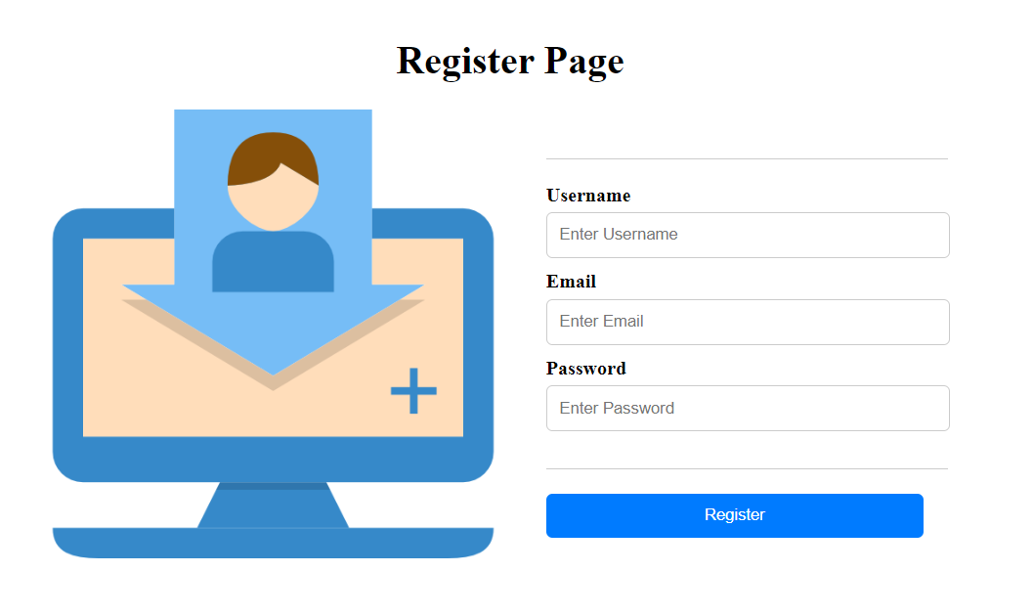

Redirect to Login

Top: LoginPage

part 1: Image

part2 : Form

Email

Password

Button

<!DOCTYPE html>

<html>

<head>

    <link rel="stylesheet" href="login.css">

</head>

<body>

    <div class="frame">

        <h1 class="page-heading">Login Page</h1>

        <div class="content">

            <div class="image-container">

                <img src="C:\Users\HPW\Downloads\Member Login.png" alt="Image">

            </div>

            <div class="form-container">

                <form action="action_page.php" method="post">

                    <label for="email"><b>Email</b></label>

                    <input type="text" placeholder="Enter Email" name="email" id="email" required>

                    <label for="psw"><b>Password</b></label>

                    <input type="password" placeholder="Enter Password" name="psw" required>

                    <button type="submit">Login</button>

                </form>

            </div>

        </div>

    </div>

</body>

</html>

body, html {

    margin: 0;

    padding: 0;

}

.frame {

    display: flex;

    flex-direction: column;

    align-items: center;

    justify-content: center;

    height: 100vh;

}

.page-heading {

    text-align: center;

}

.content {

    display: flex;

    flex-direction: row;

}

.image-container {

    width: 50%;

    margin-right: 20px; /* Adjust spacing between image and form */

}

.image-container img {

    width: 100%;

    height: auto;

}

.form-container {

    width: 50%;

    padding: 20px;

    box-sizing: border-box;

}

label {

    display: block;

    margin-bottom: 5px;

}

input[type="text"],

input[type="password"] {

    width: calc(100% - 20px); /* Adjust width to accommodate padding */

    padding: 10px;

    margin-bottom: 10px;

    border: 1px solid #ccc;

    border-radius: 5px;

}

button {

    width: calc(100% - 20px); /* Adjust width to accommodate padding */

    padding: 10px;

    background-color: #007bff;

    color: #ffffff;

    border: none;

    border-radius: 5px;

    cursor: pointer;

}

